

**Yr 7 Wood Technology – Investigation**

**TOOLS, EQUIPMENT & SAFETY TASK**

Name: ________________________________

Choose **one tool** used in woodwork. Create a **poster** for that tool. **Sketch** and **colour- in/shade** your sketch and **annotate** it’s specific features. The poster must include **7 relevant facts.** Include pictures and or charts to back up your research. You must also include **3 safety rules** associated with this tool.

**E.g: Cordless Drill sketch with annotations**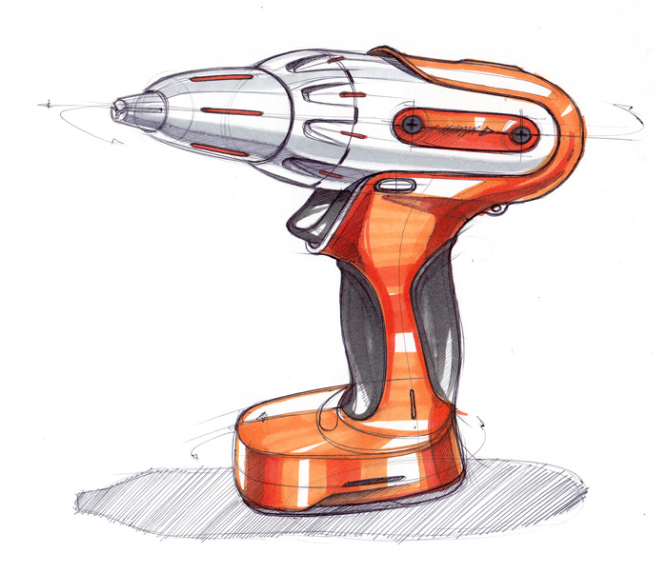

Keyless chuck

Trigger

Rechargeable Battery

Handle with rubber grip

**Cordless drill Facts:**

* Cordless drills do not have a cord which makes them easy to use on a work site
* Cordless drills use batteries for power that need to be regularly charged
* Etc.

**Cordless drill Safety Facts:**

* Never use an incompatible charger for your cordless drill. Only use the manufactures specifically designed charger for that model
* Etc.